David O Neill – 0813001 – Assignment 2 – MA4413

Q1.
------------------------------------------------------------------
The data was adjusted to display it in a readable and plotteable form.
# stem show negatively skewed data
# -4 | 4
# -3 |
# -2 |
# -1 |
# -0 | 2
# 0 |
# 1 | 669
# 2 | 01122333444445555566666777777888888899999
# 3 | 0001122222334666679
# 4 | 0

Q2
------------------------------------------------------------------
Becuase of the error in the data the standard deviation for this dataset indicates it is not normally distributed

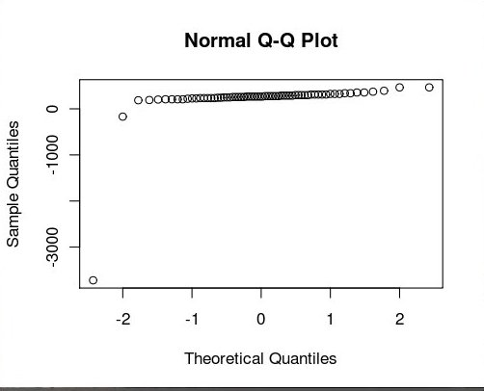

our initial assumption of negatively skewed data set was wrong
by removing the error we can now see it is positively skewed

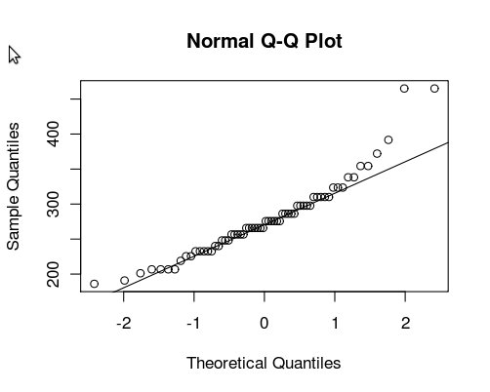

By plotting the values the data minus the negative values we get a more normal linear data indicated by the diagram.

Q3
------------------------------------------------------------------
yes normal distribution
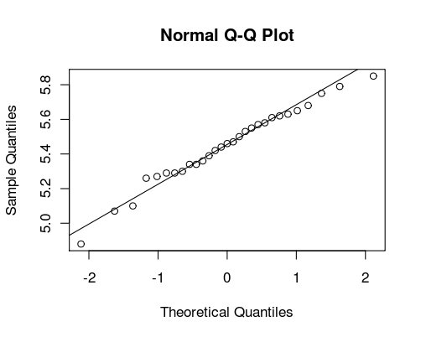

Min. 1st Qu. Median Mean 3rd Qu. Max.
4.880 5.300 5.460 5.448 5.610 5.850

Using a box plot we can see the 50% of the data is between 5.3 - 5.6
getting the mean of these would be 5.45
which is the close to the mathematical mean of the data.

Q4
------------------------------------------------------------------
Gambia had the largest increase of 56.58%
Nigeria's population of 1987 at 106700 people is greatly above the mean at 11420

Our initial view of the data does not indicate normal distribution.

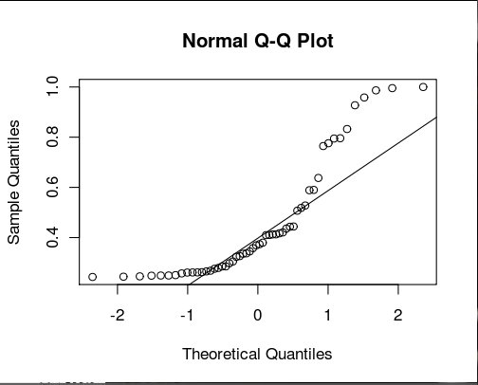

On further analysis by analyzing the interquartile
Omitting the the upper and lower (tails) we can
formalize our hypothesis that the distribution is normal .

Using the shapiro test we can obtain a p-value greater than 0.05 (0.08373) indicating
that h0 is of normal distribution
the tails or lower and higher quartiles of the distibution

~ 50% p-value = 0.08373
~ 55% p-value = 0.0688
~ 60% p-value = 0.05783

Q5
------------------------------------------------------------------
The natural log on the negatively skewed dstribution can adjust the values to more accurately describe a normal distrubtion (indicated by the HIST and qqnorm) .
The sample quantiles of the natural log is twice that of the base 10 log . In a trace analysis, using a logarithm as a transformation would adjust the values
into a noramaly distrubuted fashion.

Q6
------------------------------------------------------------------
Using the Normal Distribution Calulations
mean 3400, SD = 550

0.0509 (5.09%) of the babies are below 2500g.
0.5721 (57.21%) of the babies are below 3500g.
0.1377 (13.77%) of babies are greater than 4000g.

Q7
------------------------------------------------------------------
Using the Normal Distribution Calulations
mean = 3400, SD = 550

The babies whose weight above 90% (10%) is 4105g.
The babies below 1% is 2121g.
The babies above 95 (5%) is 4305g.
First quartile is 3029g.
The second quartile is 3400g (mean) as expected in a gaussian normal distribution.
The third quartile is 3771g.

Q8
------------------------------------------------------------------
mean = 266, SD = 16
Using the Normal Distribution Calulations

Babies percentage born before 290 ( 93.32%)
subtracting babies born before 250 days 0.1587 (15.87%)

babies between 250 and 290 days= 77.45%
babies after 205 days 0.0074%

The middle 95% of pregnancies last between 234.6 and 297.4 days
At least 296.1 days require special care

